FTP server (Windows):

1. Source download:

Install ftp server of Filezilla : <https://filezilla-project.org/>

* Filezilla server: <https://filezilla-project.org/download.php?type=server>
* Filezilla client: <https://filezilla-project.org/download.php?type=client>

1. Install:

Requied:

* Install web server: Xampp, Cpanel,…

1. Config:
2. Xampp:

Open xampp with administrator access, click start button:

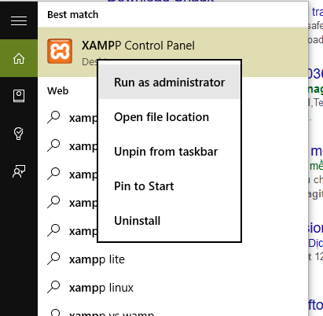

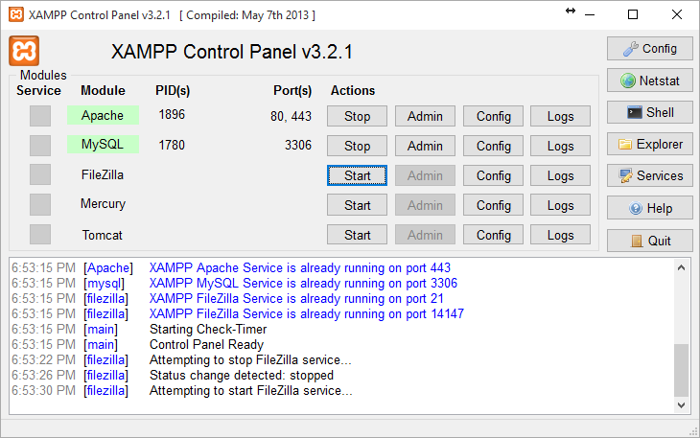

Click admin button, a dialog appear. In server address, enter your web server, this bellow, I want congig for localhost with server address is ‘*localhost*’ or ‘*127.0.0.1*’, password is null. Then click Ok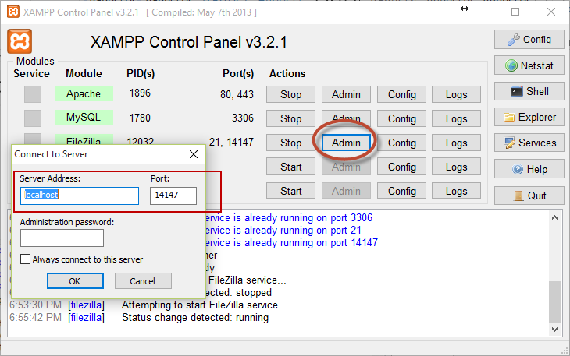

Add user for ftp:

Click in button like picture bellow or chose **Edit** menu -> User -> Add button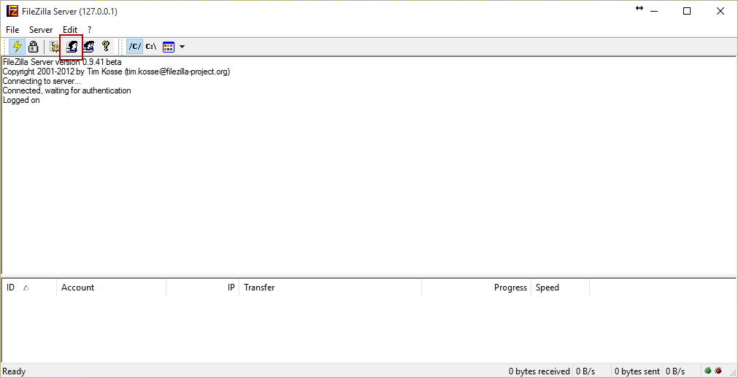

Enter user name.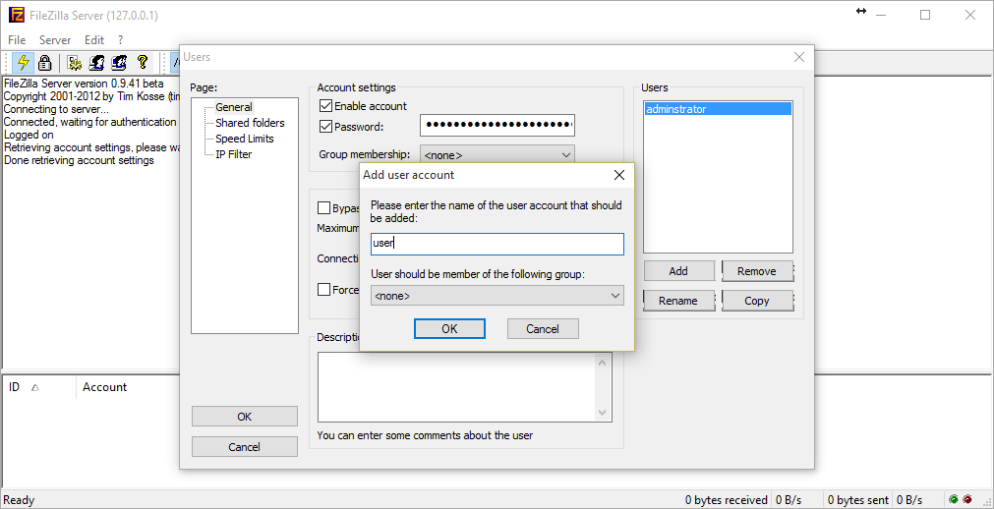

Enter password for user:

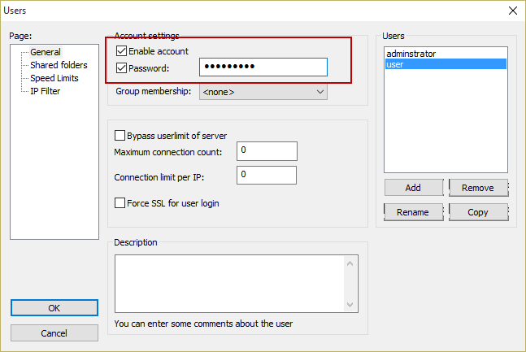

Add folder to user can access and set permission for user on that folder.

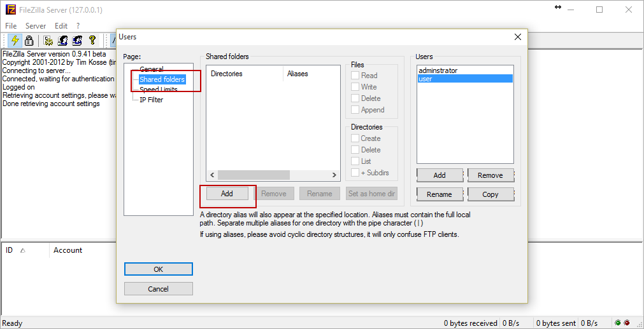

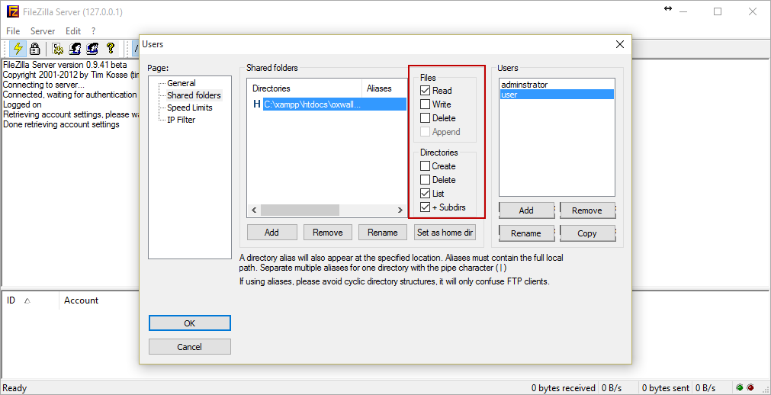

1. Other: